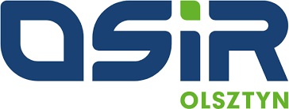
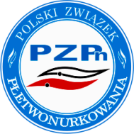
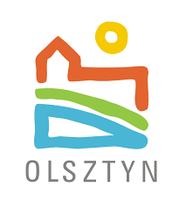
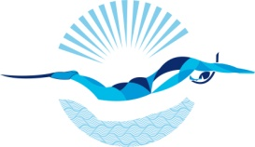
IV OPEN BALTIC
FINSWIMMING
CHAMPIONSHIP
12th - 14th March 2021

Enclosure 1
PRELIMINARY ENTRY FORM

(To be filled in and send till 28th February 2021)

We will participate in IV OPEN Finswimming Baltic Championship in Olsztyn in Poland.

Please complete this form and send it by e-mail on: biuro@pzp-n.pl

Country
Club
Address you need
on invoice

Total number of Athletes | Male |  | Female

Total number of Officials | Male |  | Female

Total number of the delegation

Date,

(Signature/ stamp)
IV OPEN BALTIC
FINSWIMMING
CHAMPIONSHIP
12th - 14th March 2021

Enclosure 2
PRELIMINARY HOTEL BOOKING FORM

(To be filled in and send till 28th February 2021)

Country
Club
e-mail |  | Phone

Accommodation - 140 euro /person

 | Number of Rooms | Date
 |  | From | To
Single
Double
Triple

Extra Nights:
If you need extra nights, please fill in the following:
 | Number of Rooms | Date
 |  | From | To
Single
Double
Triple

Date,

(Signature/ stamp)

